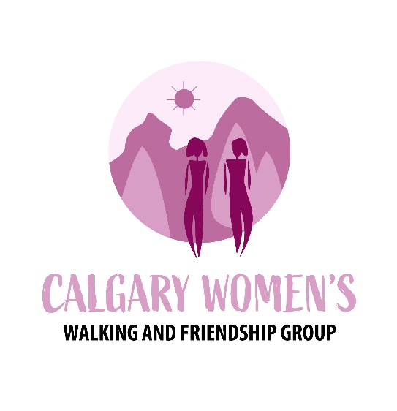

**Event Organizer and Host, Calgary Women's Walking and Friendship Group**

**We invite and welcome all Calgary women to attend our events. The Calgary Women's Walking and Friendship Group promotes events to more than one-thousand members weekly. Our website describes the walks, hikes, breakfasts, movies, museum visits and other fun social and fitness activities that Event Organizers offer weekdays, weekends and evenings throughout the year. Membership is free and most of the events are free also to encourage women to attend events and find friends.**

**EVENT WEBSITE AND FACEBOOK PAGE**

**Join the group at no cost and come to the events posted on our website here:** [**https://www.meetup.com/calgary-womens-walking-and-friendship-group/**](https://www.meetup.com/calgary-womens-walking-and-friendship-group/)

**Join our Facebook page:** [**https://www.facebook.com/groups/359823553370365**](https://www.facebook.com/groups/359823553370365)

**VISION STATEMENT**

**Welcoming, fun, social and fitness events in which women feel accepted and validated as they connect and grow their circle of friends.**

**EVENT ORGANIZER ROLE**

**No experience necessary. Organize and host an event of your choice. Examples include: walks in city parks, museum visits, movies, restaurants, and other fun activities. You are your own boss while taking adult women on a journey that allows them to become acquainted and make friends through the social and fitness events they want to attend.**

**RESPONSIBILITIES**

**- Research the events you want to host, whether you like to walk, dance, visit art galleries, hike in the mountains, meet for breakfast, or enjoy other entertainment**

**- Create your events by planning the date, time, place and other details**

**- Contact any organizations that offer events you want to attend with the women in our group**

**- Ensure ample parking spaces are available for the number of members who plan to attend**

**- Answer occasional questions from members when posted on our website**

**- Train to lead hikes (if you wish to offer hikes)**

**- Ensure any walks and fitness events you host are safe**

**- Set members at ease as they introduce themselves and connect**

**- Get everyone's attention to explain event information or safety measures**

**- Train to post the events you offer on our website (optional)**

**REQUIREMENTS**

**- Speak to groups of up to 15 women at a time when you take them around Calgary**

**- Host events with poise and grace, practicing good host behaviour (treat members as guests)**

**- Engage members during events**

**HOW TO APPLY**

**Please call 403-200-2356 or email your resume to:**

**Sue Blanchard, MBA. Email:** [**MeetupGroup@proton.me**](mailto:MeetupGroup@proton.me)**, Calgary Women's Walking and Friendship Group**

**Haven: Many refugees get hired after doing volunteer work for not-for-profit organizations.**

**I invite refugees who speak English to volunteer to help the Calgary Women's Walking and Friendship Group. No work experience is needed and training is provided for the volunteer roles below.**

**Benefits of volunteering: (1) Receive a reference letter you can send to employers. (This encourages them to hire you.) (2) Make contacts and friends by attending events hosted by the Calgary Women's Walking and Friendship Group. (3) Gain experience in leadership, online marketing, public relations, or event management.**

**The organization that needs volunteer help: The Calgary Women's Walking and Friendship Group promotes walks and other events to more than one-thousand women members weekly. We invite and welcome all Calgary women to attend our events. Our website describes the walks, hikes, breakfasts, movies, museum visits and other fun social and fitness activities that volunteer Event Organizers offer weekdays, weekends and evenings throughout the year. Membership is free and most of the events are free also to encourage women to attend the events and find friends.**

**EVENT WEBSITE AND FACEBOOK PAGE**

**New members of the group come to every event. Join the group at no cost by visiting the following event page, then come to a free event posted on our website here: https://www.meetup.com/calgary-womens-walking-and-friendship-group/**

**Join our Facebook page: https://www.facebook.com/groups/359823553370365**

**VISION STATEMENT**

**Welcoming, fun social and fitness events in which women feel accepted and validated as they meet, connect and grow their circle of friends.**

**THREE VOLUNTEER ROLES AVAILABLE**

**Training is provided.**

**1. Social Media Advisor: Develop a greater social media presence by posting our events on social media sites. Research the value of using Eventbrite to promote our events.**

**2. Event Planner: Find events for our event page. Encourage organizations and people to host event for our group in exchange for offering them the opportunity to promote their organization on our website for free. Post events on our website after learning how to do this.**

**3. Event Organizer. Attend one of our events free of cost to learn what Event Organizers do. Training is provided for the following: Organize and host an event of your choice. Examples include: (1) Host an event to meet newcomers to converse and exchange information about how to find work and get other help available to newcomers in Calgary, (2) Host walks in city parks near where you live. Women come out to chat and meet other women. You are your own boss while taking adult women on walks and on a journey that allows them to become acquainted and make friends through the social and fitness events posted on our website.**