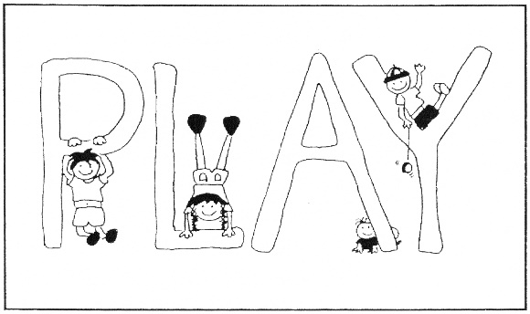

P.L.A.Y. COMMUNITY CHILD DEVELOPMENT CENTRE
1227 Kensington Close N.W.
Calgary Alberta
T2N 3J6 (403) 283-3232

